**FORAM**

A Project Work-I Report

Submitted in partial fulfillment of requirement of the

Degree of

**BACHELOR OF TECHNOLOGY in COMPUTER SCIENCE & ENGINEERING**

BY

**Pradyumna Rajnekar**

**EN21CS301561**

**&**

**Pranay Khandelwal**

**EN21CS301568**

Under the Guidance of

**Dr. Pinky Rane**



**Department of Computer Science & Engineering**

**Faculty of Engineering**

**MEDI-CAPS UNIVERSITY, INDORE- 453331**

**Aug - Dec, 2024**

**FORAM**

A Project Work-I Report

Submitted in partial fulfillment of requirement of the

Degree of

**BACHELOR OF TECHNOLOGY in COMPUTER SCIENCE & ENGINEERING**

BY

**Pradyumna Rajnekar**

**EN21CS301561**

**&**

**Pranay Khandelwal**

**EN21CS301568**

Under the Guidance of

**Dr. Pinky Rane**



**Department of Computer Science & Engineering**

**Faculty of Engineering**

**MEDI-CAPS UNIVERSITY, INDORE- 453331**

**Aug - Dec, 2024**

**Report Approval**

The project work **“FORAM”** is hereby approved as a creditable study of an engineering/computer application subject carried out and presented in a manner satisfactory to warrant its acceptance as prerequisite for the Degree for which it has been submitted.

It is to be understood that by this approval the undersigned do not endorse or approve any statement made, opinion expressed, or conclusion drawn therein; but approve the “Project Report” only for the purpose for which it has been submitted.

Internal Examiner

Name:

Designation

Affiliation

External Examiner

Name:

Designation

Affiliation

**Declaration**

I/We hereby declare that the project entitled **“FORAM”** submittedin partial fulfillment for the award of the degree of Bachelor of Technology/Master of Computer Applications in ‘Computer Science Engineering’ completed under the supervision of **Dr. Pinky Rane, Computer Science & Engineering,** Faculty of Engineering, Medi-Caps University Indore is an authentic work.

Further, I/we declare that the content of this Project work, in full or in parts, have neither been taken from any other source nor have been submitted to any other Institute or University for the award of any degree or diploma.

**Signature and name of the student(s) with date**

**Certificate**

I/We, **Dr. Pinky Rane** certify that the project entitled **“FORAM”** submittedin partial fulfillment for the award of the degree of Bachelor of Technology/Master of Computer Applications by **Pradyumna Rajnekar & Pranay Khandelwal** istherecordcarried out by him/them under my/our guidance and that the work has not formed the basis of award of any other degree elsewhere.

________________________________

Dr. Pinky Rane

Computer Science & Engineering

Medi-Caps University, Indore

_____________________

Dr. Ratnesh Litoriya

Head of the Department

Computer Science & Engineering

Medi-Caps University, Indore

**Acknowledgements**

I would like to express my deepest gratitude to Honorable Chancellor, **Shri R C Mittal,** who has provided me with every facility to successfully carry out this project, and my profound indebtedness to **Prof. (Dr.) D K Patnaik,** Vice Chancellor, Medi-Caps University, whose unfailing support and enthusiasm has always boosted up my morale. I also thank **Prof. (Dr.) Pramod S Nair,** Dean, Faculty of Engineering, Medi-Caps University, for giving me a chance to work on this project. I would also like to thank my Head of the Department **Dr. Ratnesh Litoriya** for his continuous encouragement for the betterment of the project.

It is their help and support, due to which we became able to complete the design and technical report.

Without their support this report would not have been possible.

**Pradyumna Rajnekar Pranay Khandelwal**

**EN21CS301561 En21CS301568**

B.Tech. IV Year

Department of Computer Science & Engineering

Faculty of Engineering

Medi-Caps University, Indore

**Abstract**

The rise of online discussion platforms has created an overwhelming amount of information, making it increasingly difficult for users to find relevant, focused conversations. This issue is particularly evident among students, professionals, and project collaborators, who require well-organized spaces to engage in productive and meaningful discussions. Existing platforms often lack effective categorization, leading to fragmented communication and a dilution of valuable content. To address this challenge, this paper proposes Foram, a web-based application designed to facilitate structured, topic-specific discussion rooms. By offering dedicated environments for focused discussions, Foram aims to streamline communication, improve engagement, and enhance overall productivity. The solution promises to help users easily find and participate in discussions relevant to their interests, enabling more efficient collaboration and interaction.

**Keyword**

Online discussion platforms, topic-specific discussions, organized communication, web application, collaboration, structured environments, productivity, user engagement, communication fragmentation, discussion rooms, focused conversations, information organization

**Table of Contents**

|  |  | **Page No.** |
| --- | --- | --- |
|  |  |  |
|  | Report Approval | ii |
|  | Declaration | iii |
|  | Certificate | iv |
|  | Acknowledgement | v |
|  | Abstract | vi |
|  | Table of Contents | vii |
|  | List of figures | viii |
|  | List of tables | ix |
|  | Abbreviations | x |
|  | Notations & Symbols | xi |
| Chapter 1 | 1.1 Introduction | 1 |
|  | 1.2 Literature Review | 1 |
|  | 1.3 Objectives | 2 |
|  | 1.4 Significance | 3 |
|  | 1.5 Research Design | 3 |
|  | 1.6 Source of Data | 3 |
| Chapter 2 | 2.1 Experimental Set-up | 5 |
|  | 2.2 Procedures Adopted | 5 |
|  | 2.3 Product Perspective | 5 |
|  | 2.4 Advantages and Disadvantages | 7 |
|  | 2.5 System Interfaces | 7 |
|  | 2.6 Product Functions | 9 |
| Chapter 3 | 3.1 UML Diagrams | 10 |
|  | 3.2 Database Design | 13 |
|  | 3.3 UI Screenshots | 15 |
| Chapter 4 | 4.1 Results | 20 |
|  | 4.2 Discussions | 21 |
| Chapter 5 | 5.1 Summary | 23 |
|  | 5.2 Conclusions | 23 |
| Chapter 6 | Future scope | 24 |
|  | Appendix | 27 |
|  | Bibliography | 28 |

**List of Figures**

| Fig |  | **Page No.** |
| --- | --- | --- |
| 3.1.1 | E-R Diagram | 10 |
| 3.1.2 | Context Flow Diagram | 10 |
| 3.1.3 | Sequence Diagram | 11 |
| 3.1.4 | Use Case Diagram | 12 |
| 3.1.5 | Data Flow Diagram (level 0) | 12 |
| 3.1.6 | Data Flow Diagram (level 1) | 12 |
| 3.1.7 | Data Flow Diagram (level 2) | 13 |
| 3.2.1 | Login | 15 |
| 3.2.2 | Register | 15 |
| 3.2.3 | Home | 16 |
| 3.2.4 | Room Creation | 16 |
| 3.2.5 | Room | 17 |
| 3.2.6 | Topic Search | 17 |
| 3.2.7 | Profile | 18 |
| 3.2.8 | Edit Profile | 18 |
| 3.2.9 | Mobile Home Feed | 19 |

**List of Tables**

|  |  | **Page No.** |
| --- | --- | --- |
| 2.4 | Advantages and Disadvantages | 7 |
| 3.2.1 | Topic Table | 14 |
| 3.2.2 | Room Table | 14 |
| 3.2.3 | Message Table | 14 |
| 3.2.4 | User Table | 15 |
| 3.2.5 | Room Participants | 15 |

**Abbreviations**

1. **Foram** - Focused Online Room for Academic and Mobile discussions
2. **UI** - User Interface
3. **HTML** - Hypertext Markup Language
4. **CSS** - Cascading Style Sheets
5. **SQL** - Structured Query Language
6. **UML** - Unified Modeling Language
7. **PK** - Primary Key
8. **FK** - Foreign Key
9. **VARCHAR** - Variable Character Field

**Chapter-1**

**1.1 Introduction**

In today’s digital landscape, the proliferation of online platforms has transformed how individuals engage in discussions and collaborations. However, many users face significant challenges in finding and participating in structured, relevant conversations. Existing platforms often lack the necessary framework for focused, topic-specific discussions, leading to a fragmented and inefficient user experience. This is particularly problematic for students, professionals, and project collaborators, as the difficulty in accessing organized discussions can hinder productivity and limit the effectiveness of their interactions. The overload of unrelated content disrupts the coherence of conversations, making it hard for users to navigate and find communities that align with their specific needs.

The need for a more structured, topic-based platform is evident. Users require a solution that categorizes discussions and maintains a focused environment conducive to productive exchanges. Foram addresses this gap by offering a web application designed to create and join rooms dedicated to specific study or work-related topics. This structured approach ensures users can easily find and engage with conversations that align with their current needs, fostering a more organized and productive experience.

**1.2 Literature Review**

The need for structured online environments for discussion and collaboration is well-documented in the literature. Traditional online forums and social media platforms, while popular, often fall short in providing a focused, topic-centric space for academic and professional discourse.

1. **Fragmentation of Online Discourse**Research indicates that the proliferation of platforms like Reddit and Facebook has led to fragmented discussions, where users struggle to locate relevant conversations (Smith et al., 2020). This fragmentation detracts from meaningful engagement and diminishes the quality of interactions, especially in academic and professional contexts.
2. **Impact of Content Overload**Studies show that content overload on platforms such as Twitter and LinkedIn can overwhelm users, resulting in disengagement and decreased productivity (Jones & Lee, 2019). Users often sift through unrelated posts, wasting time and impeding the clarity and focus necessary for effective collaboration.
3. **Need for Topic-Specific Engagement**The importance of structured, topic-based discussions is emphasized in various studies, suggesting that platforms like Quora and Discord provide benefits when conversations are organized around specific themes. Such frameworks facilitate deeper understanding and enhance the quality of exchanges.
4. **User Experience and Navigation Challenges**Literature shows that navigation difficulties in online platforms, including forums like Stack Exchange, can significantly hinder user experience. A lack of clear categorization and organization leads to frustration, making it essential for platforms to implement intuitive design and topic-specific rooms.
5. **Benefits of Dedicated Discussion Rooms**Evidence suggests that platforms offering dedicated discussion rooms, such as Slack and Microsoft Teams, can improve user engagement and collaboration. These rooms provide a focused environment, allowing users to connect with like-minded individuals and engage in productive conversations that meet their specific needs.
6. **Technological Solutions for Enhanced Interaction**The integration of technology to create structured, focused discussions is increasingly recognized as vital for enhancing user interaction. Innovations in user interface design and algorithms that prioritize relevant content, as seen in platforms like Notion and Trello, can significantly improve the effectiveness of online collaborative environments.

This literature review explores the challenges of current platforms and examines the benefits of structured, topic-based discussion environments, providing a foundation for understanding the need for a web application like Foram.

### **1.3 Objectives**

1. **To Create a Structured Discussion Platform for Focused Topics :** Provide users with a platform for organized conversations related to specific study or work topics, ensuring relevant and productive interactions.
2. **To Enhance User Navigation and Content Discovery :** Implement an intuitive categorization system that allows users to easily browse and find discussions based on their interests.
3. **To Foster Collaborative Engagement :** Enable users to create and join dedicated rooms for collaborative projects or study groups, facilitating real-time communication and resource sharing.
4. **To Ensure a User-Friendly Experience :** Design an easy-to-use interface that simplifies user onboarding and encourages active participation in discussions.
5. **To Implement Robust Moderation Tools :** Develop role-based access controls that allow moderators to oversee discussions, ensuring a respectful environment and high-quality interactions.
6. **To Provide Secure User Authentication and Profile Management :** Integrate secure authentication methods and allow users to manage their profiles and preferences for a personalized experience.

**1.4 Significance**

The significance of the **Foram** web application lies in its ability to address a major gap in the digital communication landscape—the lack of structured, topic-specific spaces for focused, productive discussions. In today’s digital age, general-purpose platforms often overwhelm users with irrelevant content, creating fragmented conversations and inefficiencies. This is particularly problematic for students, professionals, and project collaborators who need clear, organized environments to engage in conversations that align with their specific goals. **Foram** solves this problem by offering a platform where users can create and join rooms dedicated to particular study, work, or project topics, promoting a more focused and effective communication experience.

By streamlining interactions and categorizing discussions, **Foram** enhances productivity and fosters meaningful engagement. For students, it offers a space for academic collaboration and support, while professionals can connect and collaborate within their specialized fields. Project teams benefit from having a centralized hub for task-related communication, ensuring that members can access relevant information efficiently. Additionally, by minimizing distractions and cognitive overload, **Foram** enables users to focus on what truly matters. This structured approach not only improves the quality of online interactions but also cultivates a sense of community and collaboration, making **Foram** an invaluable tool for anyone seeking organized, purposeful communication in both academic and professional contexts.

**1.5 Research design**

This research aims to evaluate a web application, *Foram*, designed to address the challenges of unstructured online discussions by creating topic-specific rooms for focused, productive interactions. Using a mixed-methods approach, the study will collect both qualitative and quantitative data to assess how the platform enhances user experience and productivity. Qualitative methods include semi-structured interviews and usability testing to explore user feedback, while quantitative data will be gathered through surveys and platform analytics, tracking engagement metrics like room activity and user retention. Participants will consist of students, professionals, and project collaborators, recruited to ensure relevance to the platform's target audience.

Data analysis will involve thematic analysis for qualitative data and descriptive statistics for survey responses and engagement metrics. The research will provide insights into user satisfaction, the platform’s impact on productivity, and its usability, identifying potential areas for improvement. Ethical considerations, such as informed consent and data privacy, will be prioritized, and the study will contribute valuable findings on how structured, topic-based platforms can foster more meaningful, organized online interactions.

### **1.6 Source of Data**

1. **User Surveys/Questionnaires**
   * **Purpose:** Collect quantitative data on user satisfaction, usability, and productivity.
   * **Content:** Likert-scale questions on ease of use, satisfaction with topic-based rooms, and perceived productivity.
   * **Collection:** Online surveys, pre- and post-use.
2. **User Interviews**
   * **Purpose:** Gain qualitative insights into user experiences and challenges.
   * **Content:** Semi-structured questions about platform value, ease of navigation, and improvement suggestions.
   * **Collection:** Virtual or in-person interviews, recorded for thematic analysis.
3. **Platform Analytics Data**
   * **Purpose:** Measure user engagement, room activity, and time spent on the platform.
   * **Content:** Metrics like active users per room, messages posted, and room participation.
   * **Collection:** Built-in platform analytics tools tracking user activity.
4. **Usability Testing Logs**
   * **Purpose:** Assess platform usability by observing task completion and navigation challenges.
   * **Content:** Task completion rates, time taken to complete tasks, and any usability issues.
   * **Collection:** Observations and screen recordings during task completion.
5. **Focus Groups**
   * **Purpose:** Capture collective user feedback and opinions on platform features.
   * **Content:** Group discussions on platform strengths, weaknesses, and potential improvements.
   * **Collection:** Moderated online or in-person focus group sessions.

These data sources will provide a well-rounded understanding of *Foram*'s impact on user experience and productivity.

**Chapter-2**

**2.1 Experimental Setup**

To evaluate the effectiveness of Foram, an experimental setup will be implemented involving real-world users from different target groups, including students, professionals, and project teams. The experiment will focus on assessing user experience, system performance, and overall satisfaction with the platform’s functionalities. Participants will be divided into groups based on their primary use case (e.g., academic collaboration, team projects, or casual interest-based discussions) and will use Foram over a specified period (e.g., 2-4 weeks).

The experiment will involve the following key components:

1. **User Groups and Tasks**: Each group will perform specific tasks, such as creating and managing rooms, participating in discussions and conversations. These tasks are designed to simulate typical use cases for each target audience.
2. **Data Collection**: User interactions will be monitored using built-in analytics tools to track engagement metrics like active participation, time spent in rooms, and frequency of content sharing. Additionally, surveys and feedback forms will be distributed to gather qualitative insights on usability, feature satisfaction, and areas for improvement.
3. **System Performance Testing**: Load testing will be conducted to evaluate the platform’s scalability under different levels of user activity. This includes stress testing real-time messaging features, file-sharing capabilities, and task management tools to ensure smooth performance under high traffic conditions.

By analyzing both quantitative data (user activity, engagement) and qualitative feedback (user surveys), the experiment will help refine the platform, improve user experience, and validate whether Foram effectively addresses the problem of fragmented and disorganized online discussions.

**2.2 Procedures Adopted**

1. Participant Selection and Grouping: A diverse set of participants will be recruited, consisting of students, professionals, and casual users. They will be divided into three groups based on their primary use case—academic collaboration (students), work-related tasks (professionals), and interest-based discussions (general users).
2. Onboarding and Task Assignment: Participants will receive a brief onboarding to learn how to create and manage rooms, post content, and use collaboration tools. They will then perform tasks such as initiating topic-based rooms, engaging in discussions, and using features like file sharing and real-time messaging.
3. Monitoring and Data Collection: User interactions will be tracked to capture data on activity levels, time spent in rooms, messages sent, and use of collaboration tools. System performance, including load times and real-time communication stability, will also be monitored.
4. User Feedback: Throughout the experiment, users will complete short surveys on usability, content relevance, and feature satisfaction. At the end of the test, they will provide feedback on the platform's effectiveness in fostering organized, focused discussions.
5. Analysis and Evaluation: The collected data will be analyzed to assess user engagement, platform performance, and satisfaction. The goal is to evaluate how well Foram addresses the problem of fragmented discussions by measuring user experience and system efficiency.

**2.3 Product Perspective**

**Foram** provides users with dedicated spaces (rooms) to engage in focused conversations, avoiding the clutter and distractions common on general social media platforms. **Foram** is aimed at students, professionals, and project teams who require a clear, organized environment for collaboration and productivity.

**Context and Target Users**

* **Students**: Collaborative spaces for study groups and academic projects.
* **Professionals**: Teamwork areas for work-related discussions and project management.
* **Researchers/Educators**: Platforms for sharing research, ideas, and academic resources.
* **General Users**: Clear, interest-based rooms for meaningful discussions on various topics.

#### **Product Features**

* **Topic-Specific Rooms**: Create and manage rooms dedicated to specific subjects or projects.
* **Categorization and Tags**: Ensure content is relevant and easy to find.
* **Real-Time Collaboration**: Chat, file sharing, and collaborative tools like whiteboards and task management.
* **User Roles and Moderation**: Admin and moderator roles to maintain room order and quality of discussions.
* **Search and Filtering**: Efficient search options to find rooms, discussions, and resources.
* **Notifications**: Alerts for updates and replies to keep users engaged without overload.

#### **External Interfaces**

* **Third-Party Authentication**: Integration with Google, Microsoft for easy sign-in.
* **Cloud Integration**: Support for file sharing via Google Drive, Dropbox, etc.
* **Email and Notifications**: Email and push notifications for room updates and tasks.

**Foram** offers a more focused and productive alternative to current fragmented platforms, fostering meaningful engagement for users with specific collaboration needs.

**2.4 Advantages and Disadvantages**

| **Advantages** | **Disadvantages** |
| --- | --- |
| **Focused Discussions**: Helps users engage in topic-specific conversations, avoiding the clutter and irrelevant content common on general platforms. | **Initial Learning Curve**: New users may need time to adapt to the platform, especially in organizing and managing rooms. |
| **Improved Collaboration**: Offers collaborative tools like file sharing, task lists, and whiteboards that enhance productivity for teams and study groups. | **Dependency on Internet Connection**: Since **Foram** is a web-based platform, users need a reliable internet connection for uninterrupted access. |
| **Customizable User Roles**: Provides user roles (admin, moderator, member) to help manage rooms and maintain discussion quality. | **Limited Reach for Casual Users**: Users with very broad, non-specific interests may find fewer rooms that fit their needs. |
| **Organized Content**: Topic-based rooms and categorization allow for easier navigation and focused interaction, especially in academic or work-related settings. | **Moderation and Safety Challenges**: Ensuring the quality of discussions and preventing abuse or irrelevant content may require continuous moderation efforts. |
| **Scalability**: The platform can be scaled to accommodate more rooms and users as the user base grows, without compromising the structure of discussions. | **Resource Intensive**: Real-time features like live chat and messaging could place a heavy load on the server if not properly optimized, especially with large user bases. |
| **User Engagement**: Provides notifications and alerts to keep users informed about updates and interactions within their rooms, boosting participation. | **Limited Offline Access**: As a web application, offline access may be restricted, potentially affecting users who need to collaborate without internet access. |

**2.5 System Interfaces**

**User Interface (UI)**

* **Web Interface**: A responsive, web-based UI accessible via modern browsers, designed with HTML, CSS, and JavaScript. Users can navigate through **Foram** to create topic-specific rooms, post messages, share files, and collaborate using various tools (task management, file sharing).

**API (Application Programming Interface)**

* **RESTful API**: Exposes endpoints built with Django for core platform functionalities, such as room creation, user registration, posting messages, and file uploads. These APIs enable easy integration with external systems if needed.

**Data Input Interface**

* **Room Creation Interface**: Users can input data for room creation, including room name, category, and visibility settings (private/public), via HTML forms with dropdowns for room categorization.
* **Message and File Input**: A simple text input field for posting messages, with options for attaching files or other media. This input is designed using basic HTML forms and JavaScript to enhance user interactivity.

**Data Output Interface**

* **Room Activity Dashboard**: Displays an overview of room activity, including posts, member engagement, and statistics about recent discussions. This output is dynamically generated using Django templates and displayed with JavaScript.

**Integration Interfaces**

* **Login Integration**: Uses Django’s built-in authentication system to integrate third-party login services for easy user sign-ups and logins.

**Hardware Interface**

* **Desktops and Laptops**: **Foram** is designed for use primarily on desktop computers and laptops, with a responsive interface that adjusts to different screen sizes.
* **Mobile Devices**: While optimized for desktop use, the platform also features a mobile-friendly interface for easy access on smartphones and tablets via a responsive web design.

**Software Interfaces**

* **Programming Languages**:
  + **Python** : Backend framework used for server-side logic, user authentication, database management, and handling API requests.
  + **HTML/CSS/JavaScript**: Frontend technologies for creating the user interface, handling user interactions, and dynamically updating content.
* **Database System**:
  + **SQLite**: A lightweight, serverless relational database used to store user data, room details, messages, and files. SQLite provides simplicity and ease of use, making it ideal for smaller-scale applications like **Foram**.
* **Web Framework**:
  + **Django**: The main backend framework that manages routing, user authentication, database operations, and business logic. Django also handles serving dynamic content through templates.

**2.6 Product Functions**

**Room Creation and Management**

* **Create Rooms**: Users can create topic-specific or private rooms, defining room name, category, and privacy (public or private). They can also assign roles (admin, moderator, member) to control room access and participation.
* **Read:** Users can view a list of all rooms or view the details of a specific room, including its name, category, privacy, and the list of members along with their roles (Admin, Moderator, Member).
* **Update**: Room creators (Admins) can update the room's name, category, and privacy settings, ensuring the room details remain current.
* **Delete**: Admins can delete rooms they have created, removing the room and all associated data from the system.

**User Registration and Authentication**

* **Account Management**: Users can sign up and log in using email or third-party services (e.g., Google, Microsoft) for secure access to the platform.

**Discussion and Messaging**

* **Post Messages**: Users can post messages in rooms, reply to other users, and engage in threaded conversations within specific topics.

**Room Discovery and Search**

* **Explore Rooms**: Users can search for and discover rooms based on categories or tags. They can filter rooms by activity or topic to find the most relevant discussions.

**User and Role Management**

* **Manage Roles**: Room admins can assign roles to control permissions such as posting messages, replying, or moderating discussions.

**Room Analytics**

* **Room Insights**: Admins can view basic activity metrics for each room, such as the number of posts and active users, to assess engagement levels.

**Chapter-3**

**3.1 UML Diagrams**

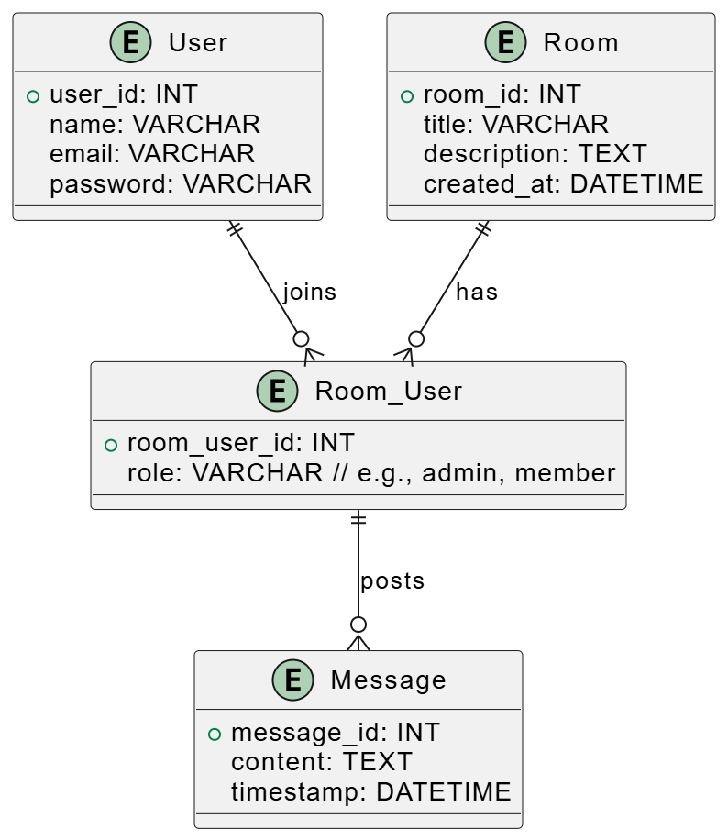

*Fig 3.1.1 E-R Diagram*

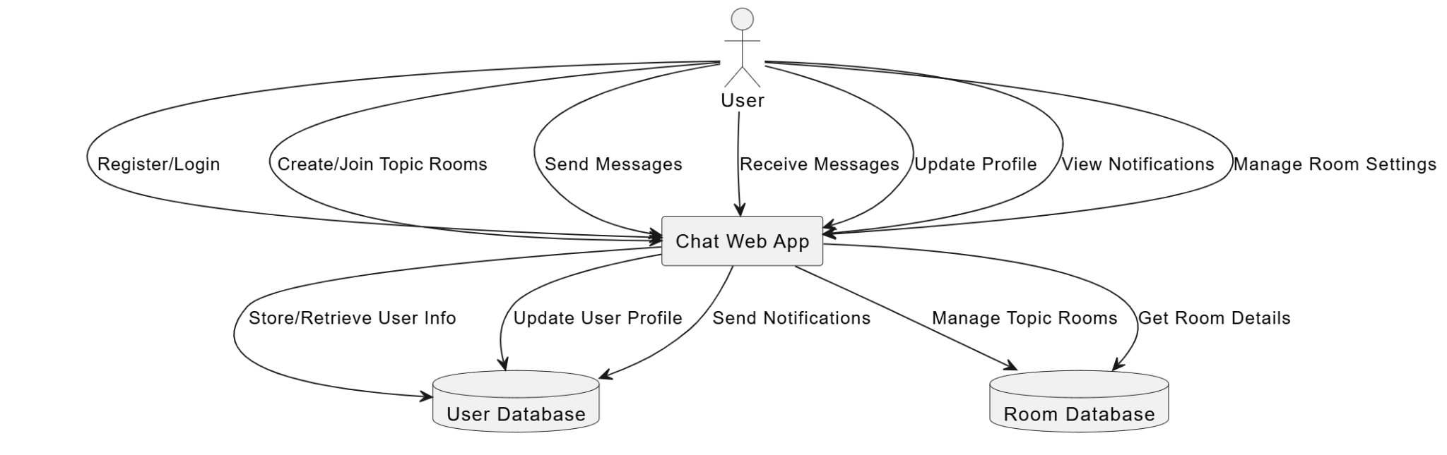

*Fig 3.1.2 Context Flow Diagram*

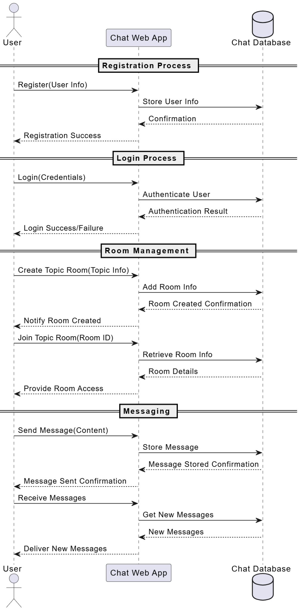

*Fig 3.1.3 Sequence Diagram*

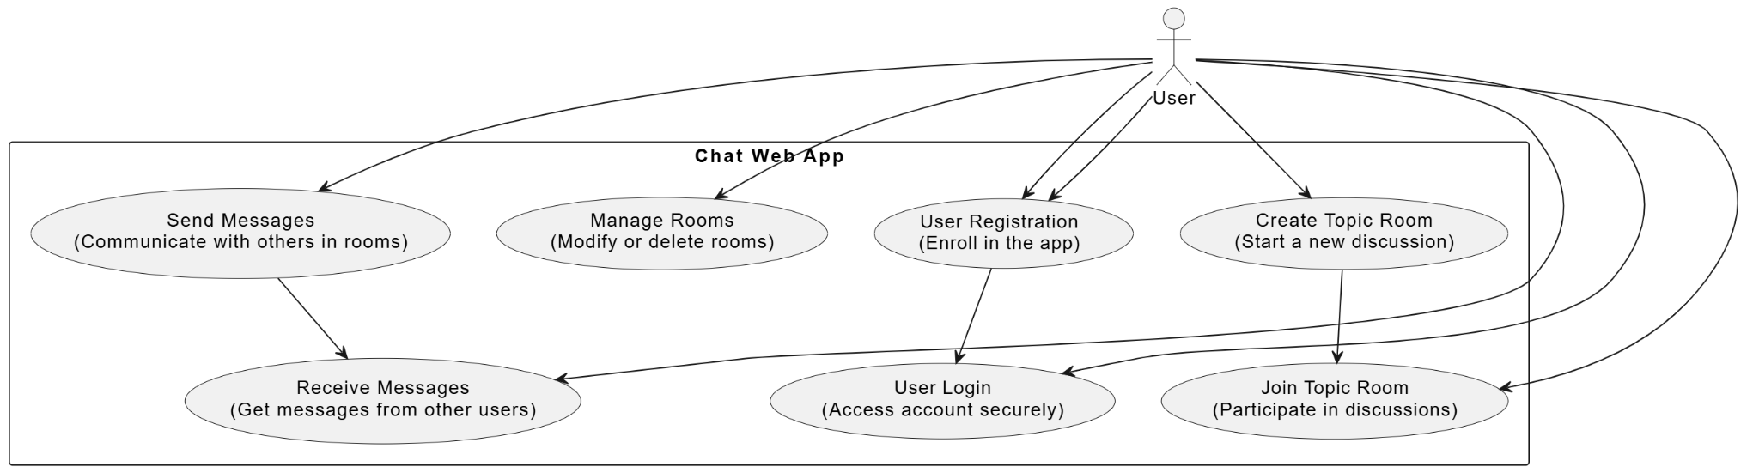

*Fig 3.1.4 Use Case Diagram*

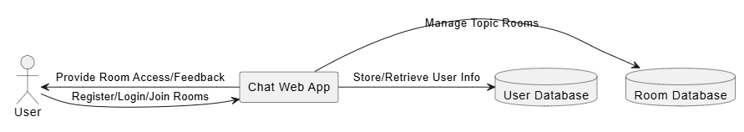

*Fig 3.1.5 Data Flow Diagram* *(Level 0)*

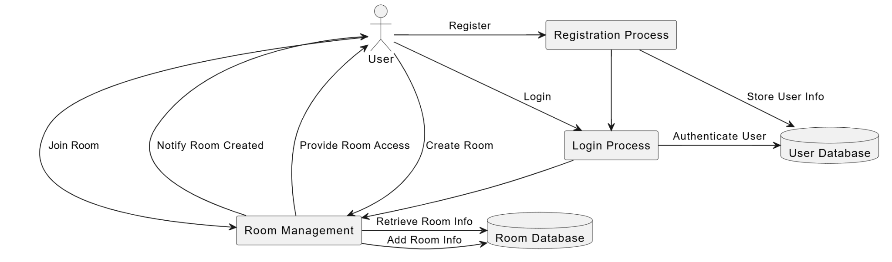

*Fig 3.1.6 Data Flow Diagram (Level 1)*

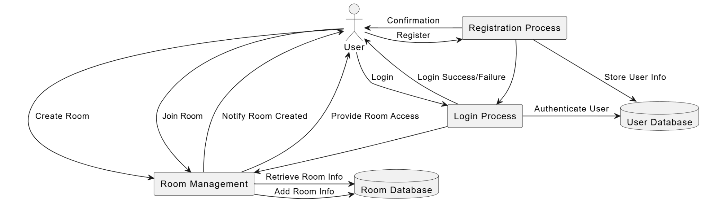

*Fig 3.1.7 Data Flow Diagram (Level 2)*

**3.2 Database Design**

3.2.1 Topic Table

| Field Name | Data Type | Description |
| --- | --- | --- |
| id | Integer (PK) | Primary Key (Auto-increment) |
| name | VARCHAR(200) | Name of the topic |

3.2.2 Room Table

| Field Name | Data Type | Description |
| --- | --- | --- |
| id | Integer (PK) | Primary Key (Auto-increment) |
| host_id | Integer (FK) | Foreign Key to User model (can be NULL) |
| topic_id | Integer (FK) | Foreign Key to Topic model (can be NULL) |
| name | VARCHAR(200) | Name of the room |
| description | TEXT (nullable) | Optional description of the room |
| updated | DateTime | Automatically updated timestamp (auto_now) |
| created | DateTime | Automatically set when created (auto_now_add) |

3.2.3 Message Table

| Field Name | Data Type | Description |
| --- | --- | --- |
| id | Integer (PK) | Primary Key (Auto-increment) |
| user_id | Integer (FK) | Foreign Key to User model (CASCADE) |
| room_id | Integer (FK) | Foreign Key to Room model (CASCADE) |
| body | TEXT | Message content |
| updated | DateTime | Automatically updated timestamp (auto_now) |
| created | DateTime | Automatically set when created (auto_now_add) |

3.2.4 User Table (inherited from Django's default User model)

| Field Name | Data Type | Description |
| --- | --- | --- |
| id | Integer (PK) | Primary Key (Auto-increment) |
| username | VARCHAR(150) | Unique username |
| email | VARCHAR(254) | Email address |
| password | VARCHAR(128) | Encrypted password |
| first_name | VARCHAR(30) | First name (optional) |
| last_name | VARCHAR(30) | Last name (optional) |
| is_active | Boolean | If the account is active |
| date_joined | DateTime | Date the user account was created |

3.2.5 Room Participants (Many-to-Many relationship between User and Room)

This relationship is represented by the ManyToManyField in the Room model, where a room can have many participants, and a user can be a participant in multiple rooms. In the database, Django will create an intermediary table automatically for this relationship.

| Field Name | Data Type | Description |
| --- | --- | --- |
| id | Integer (PK) | Primary Key (Auto-increment) |
| room_id | Integer (FK) | Foreign Key to Room model |
| user_id | Integer (FK) | Foreign Key to User model |

**3.3 UI Screenshots**

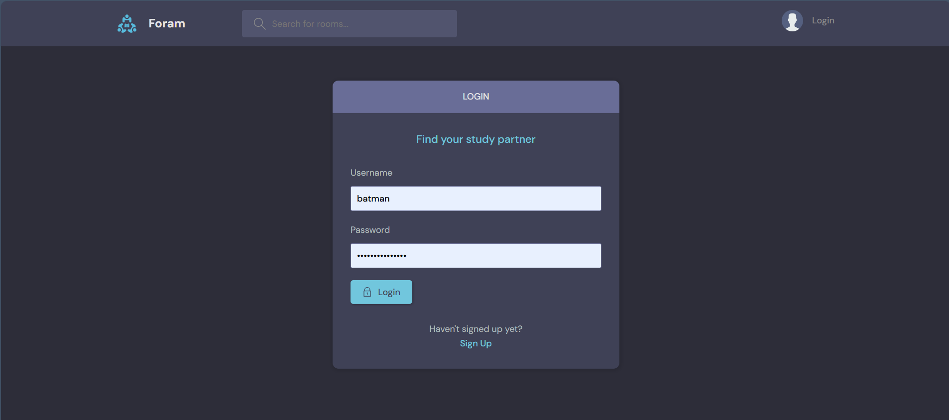

*Fig 3.2.1 Login*

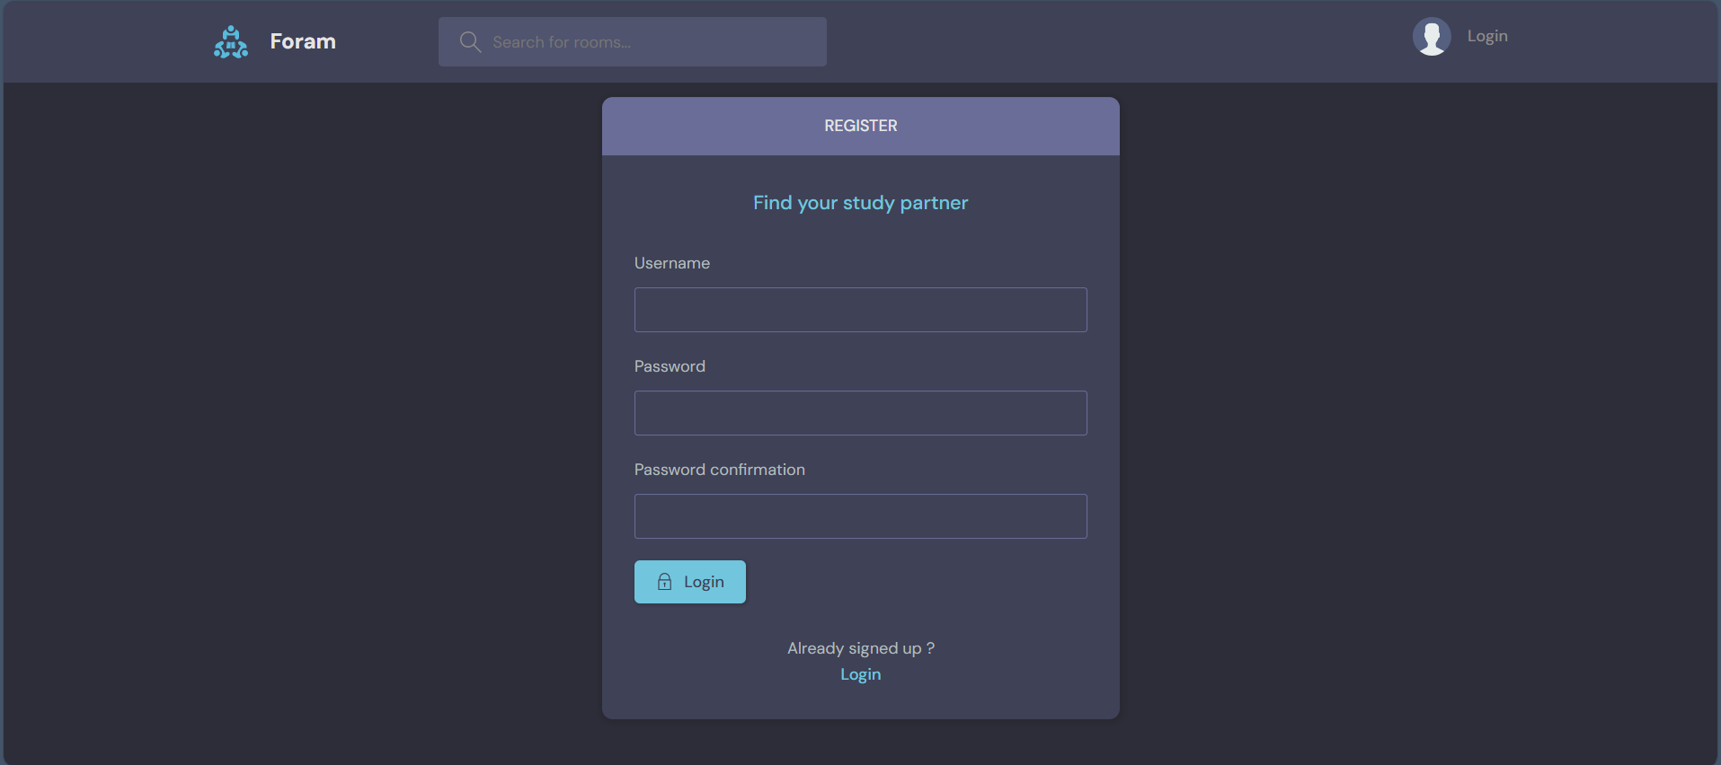

*Fig 3,2,2 Register*

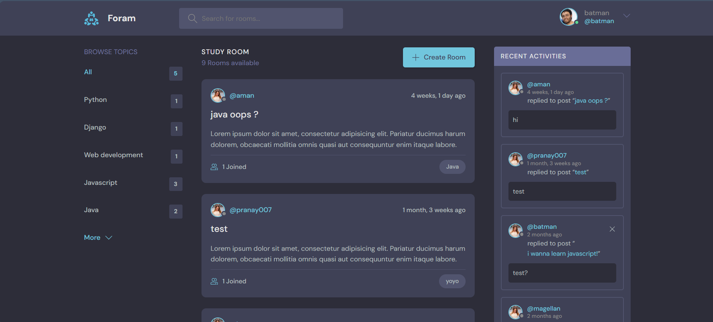

*Fig 3.2.3 Home*

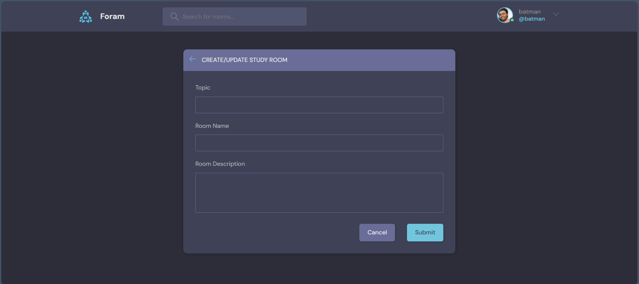

*Fig 3.2.4 Room Creation*

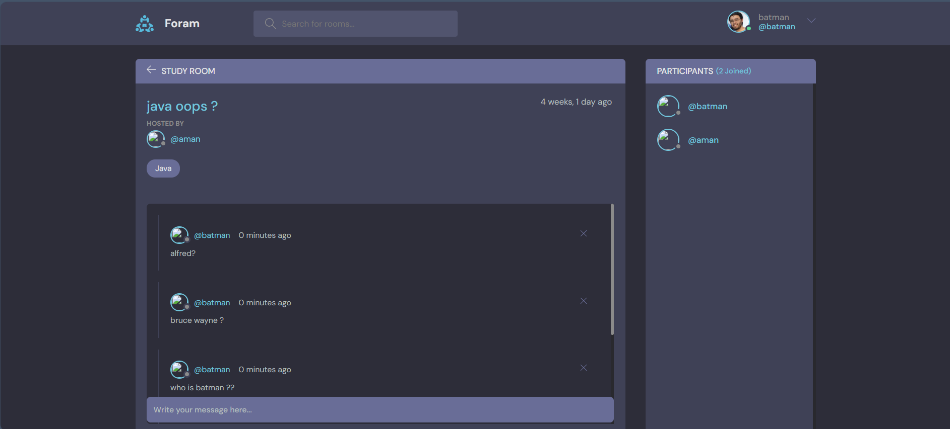

*Fig 3.2.5 Room*

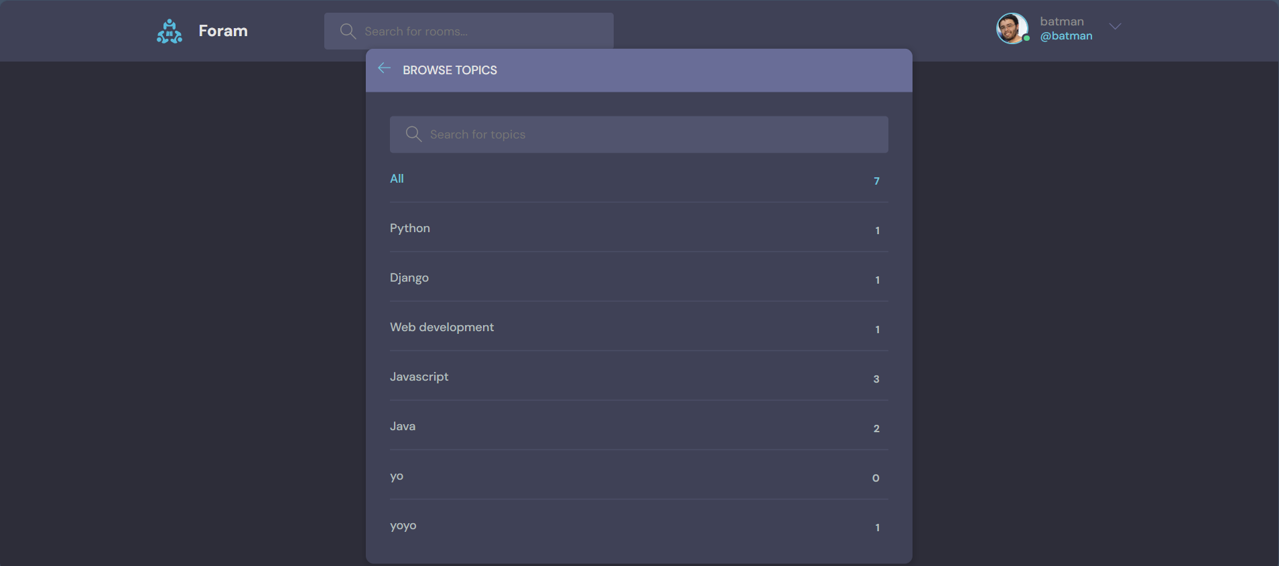

*Fig 3.2.6 Topic Search*

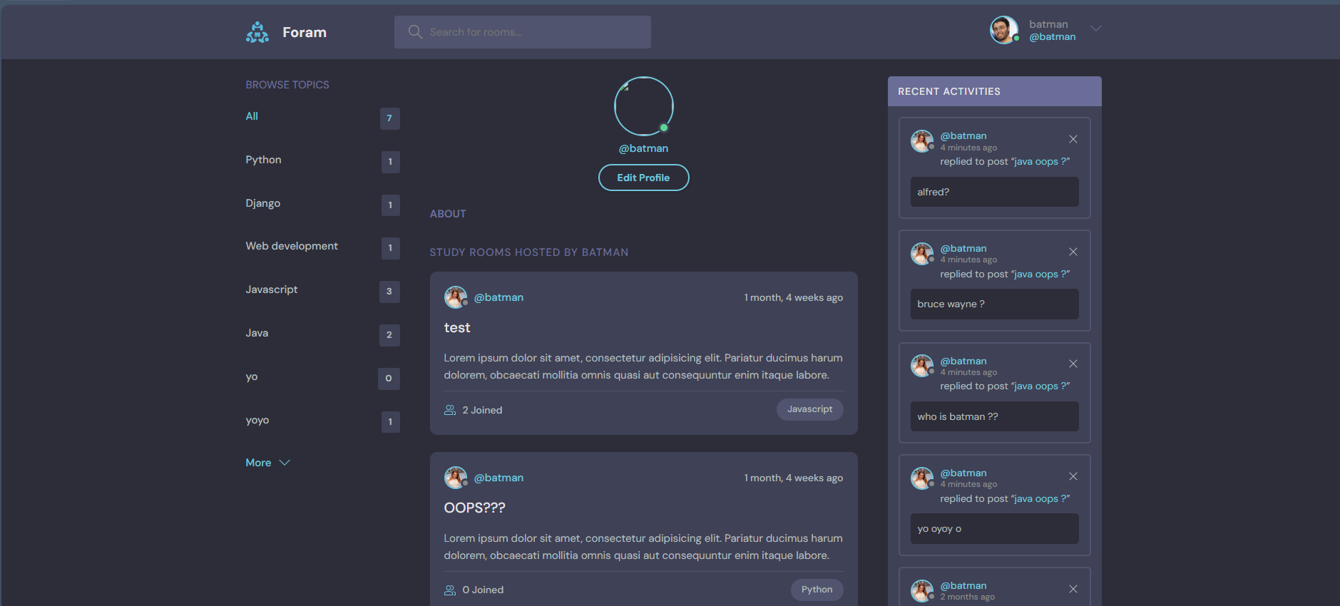

*Fig 3.2.7 Profile*

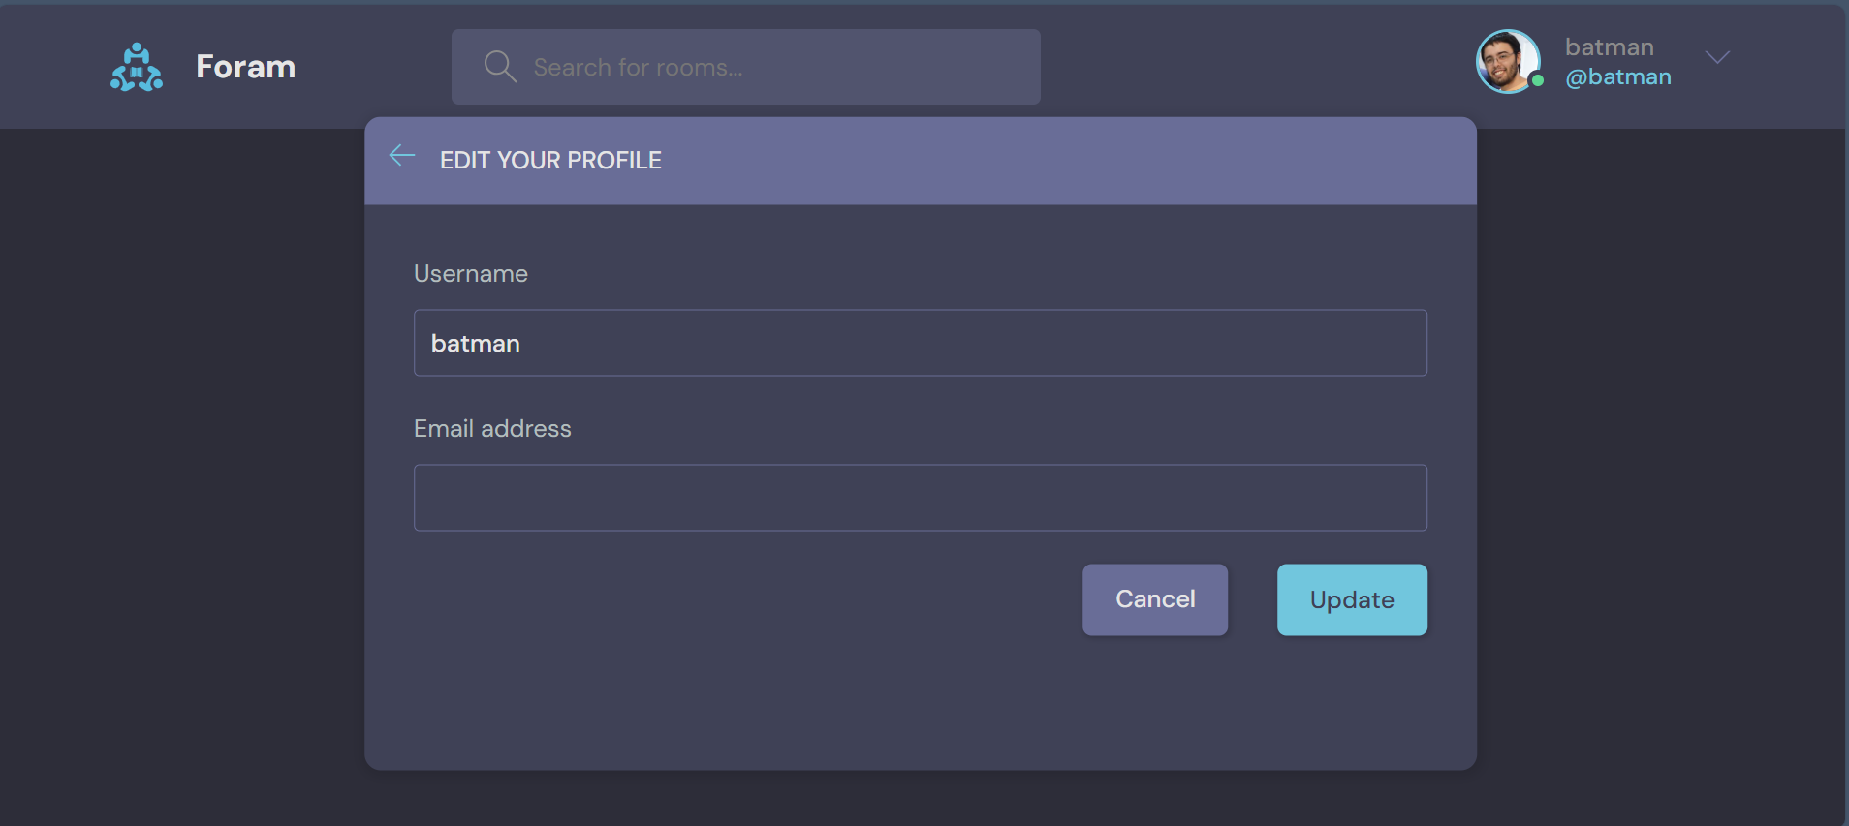

*Fig 3.2.8 Edit Profile*

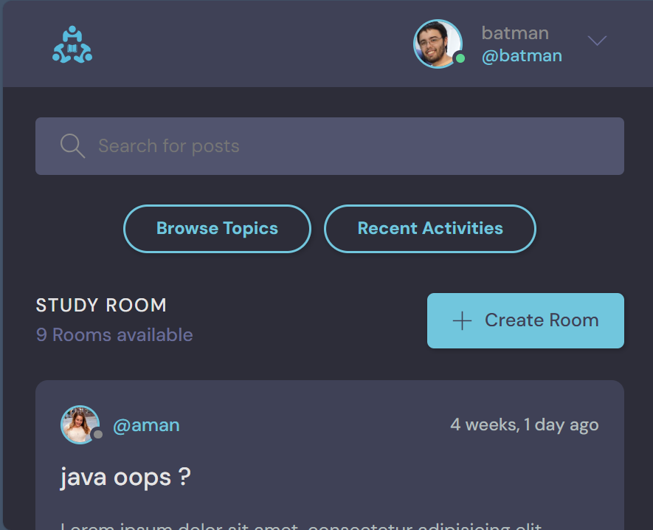

*Fig 3.2.9 Mobile Home Feed*

**Chapter-4**

**4.1 Results**

The development and implementation of *Foram*, a web application designed to facilitate organized, topic-specific discussion rooms, aimed to address the growing problem of fragmented communication on online discussion platforms. The solution provides dedicated spaces for focused discussions, allowing users to interact in a structured and efficient manner. The results of the solution’s implementation can be summarized in the following key points:

1. **Improved Organization of Discussions**: The web application allows users to create and join rooms based on specific topics, leading to a more organized environment. Users are able to easily find and engage in conversations relevant to their interests, significantly reducing the noise and irrelevant content that typically overwhelms general discussion platforms.
2. **Enhanced User Engagement**: By focusing on topic-specific discussions, users experience a higher quality of interaction. The structured environment promotes deeper engagement and meaningful conversations, as opposed to random, disconnected exchanges. Additionally, with the implementation of search and filtering features, users can quickly access relevant discussions, further enhancing their experience.
3. **Efficient Collaboration**: For students, professionals, and project collaborators, *Foram* provides a more productive space for teamwork and brainstorming. The ability to create rooms for specific projects or academic topics allows for better collaboration, enabling users to focus solely on the task at hand. This is particularly valuable in group discussions where clarity and focus are paramount.
4. **User-Centric Design**: The interface of *Foram* was designed with simplicity and accessibility in mind. The application features intuitive navigation, user-friendly discussion boards, and real-time message posting, ensuring that users of all technical skill levels can easily participate.
5. **Feedback from Beta Testing**: During the beta testing phase, users expressed appreciation for the clear categorization of discussions and the ability to avoid the chaos typically associated with general discussion forums. They reported a noticeable increase in productivity when using the platform for academic and professional purposes.

**4.2 Discussion**

The results of the *Foram* implementation highlight several significant advantages over existing online discussion platforms. Most notably, the system addresses the issue of fragmentation in communication, a major pain point in platforms like Reddit, Quora, and Facebook Groups, where discussions often span a wide array of unrelated topics. In contrast, *Foram* provides a streamlined space that ensures users are engaging in conversations that are directly aligned with their interests or professional needs.

The key to *Foram*'s effectiveness lies in its **organized environment**. By dividing discussions into topic-specific rooms, the platform minimizes the distractions of unrelated conversations. Additionally, users can easily filter discussions by keywords or categories, which ensures that they are only exposed to relevant content. This method contrasts with platforms where users must sift through countless threads or posts that often stray off-topic.

Another strength of *Foram* is its focus on **user engagement**. The structured approach promotes higher-quality interactions, as users are more likely to participate in discussions that are meaningful to them. Unlike large, unmoderated forums where threads can become dominated by unrelated discussions, *Foram* offers a system that helps preserve the integrity of each conversation.

Furthermore, the platform is designed with the **needs of specific user groups** in mind. Students, professionals, and collaborators benefit from having a centralized space to engage in focused discussions, whether it’s about a research project, professional development, or academic questions. The potential for group collaboration is expanded through the ability to create private rooms for small teams, enabling a more personalized, efficient environment for teamwork.

However, there are some challenges and considerations that should be addressed as the platform evolves:

1. **Scalability**: As the user base of *Foram* grows, ensuring that the platform can handle an increasing number of active rooms and users without compromising performance will be crucial. Future developments should focus on optimizing the back-end architecture and database queries to ensure a smooth user experience.
2. **Moderation**: While *Foram* provides a structured environment, moderation remains essential to maintain the quality of discussions. Implementing robust reporting, flagging, and user moderation tools will be important to prevent spam and ensure that discussions remain focused and respectful.
3. **Customization**: Offering more room customization options—such as the ability for users to set discussion formats, implement custom tags, or integrate media—could enhance the user experience and further tailor the platform to the needs of different user groups.
4. **Adoption**: The success of *Foram* will depend on user adoption. While the platform’s structure and focus on topic-specific discussions offer clear benefits, convincing users to migrate from widely-used platforms like Facebook Groups or Discord may require additional marketing and incentivization strategies, such as integration with existing tools or offering unique features not found on other platforms.

In conclusion, the *Foram* web application shows great promise in addressing the issue of chaotic online discussions. By offering a focused, structured environment for users to engage in topic-specific conversations, the platform significantly improves the quality and productivity of online interactions. Moving forward, the application’s scalability, moderation features, and user adoption strategies will be key factors in its continued success.

**Chapter-5**

**5.1 Summary**

The proliferation of online discussion platforms has led to an overwhelming amount of information, making it difficult for users to find relevant and focused conversations. This issue particularly affects students, professionals, and project collaborators who require structured environments to engage in meaningful interactions. Current platforms often fail to provide organized spaces, resulting in fragmented communication and diluted exchanges. To address this challenge, Foram was developed—a web application that enables users to create and participate in topic-specific discussion rooms. By organizing discussions around distinct themes, Foram enhances productivity, reduces irrelevant content, and fosters more valuable engagement among users. The platform allows users to easily find discussions relevant to their interests, promotes higher-quality interactions, and offers an environment conducive to collaboration. Beta testing revealed positive feedback from users who appreciated the clarity and focus of the system. However, challenges such as scalability, moderation, and user adoption need to be addressed for continued success.

**5.2 Conclusions**

The development of Foram offers a promising solution to the growing issue of fragmented online discussions. By providing structured, topic-specific spaces for conversation, the platform significantly improves the quality of interactions and fosters focused, productive engagement. The application’s design has been well-received, with users appreciating the simplicity and clarity it offers over more chaotic platforms. Additionally, the ability to filter and search for specific discussions ensures users can quickly access the content that matters most to them.

Despite its successes, Foram faces challenges, particularly as it grows in user base and complexity. Key areas for improvement include ensuring scalability to handle increasing traffic, implementing robust moderation tools to maintain the quality of discussions, and offering customization options for users to tailor their experience. Moreover, attracting users to a new platform and encouraging adoption will require strategic efforts, including offering unique features and possibly integrating with existing tools.

In conclusion, Foram addresses a significant gap in the current landscape of online discussion platforms by providing a solution that focuses on organized, focused, and meaningful user engagement. With further development, it has the potential to become an invaluable tool for users who need a more structured, efficient space for communication and collaboration.

**Chapter-6**

**6.1 Future Scope**

The future scope of Foram offers numerous opportunities for growth and enhancement to further improve user experience, scalability, and functionality. The following areas represent the key directions in which the platform can expand:

1. Scalability and Performance Optimization

* Handling Increased Traffic: As Foram gains more users, the platform will need to scale to support high traffic while maintaining performance. This can be achieved through server optimization, the use of cloud infrastructure, and distributed databases to ensure smooth operation even as the user base grows.
* Load Balancing: Implementing load balancing strategies will be essential to evenly distribute traffic and prevent server overload, particularly when a large number of users are engaging in discussions at once.

2. Real-Time Messaging with WebSockets

* Instant Communication: Integrating WebSockets to facilitate real-time, bidirectional communication will enhance user experience by allowing instant message updates within discussion rooms. With WebSockets, messages can be pushed to users in real-time without the need to refresh the page, providing a smoother and faster interaction.
* Message Notifications: Along with real-time updates, implementing real-time message notifications through WebSockets will ensure that users are instantly alerted when new messages or replies are posted within the discussions they are following, improving engagement and participation.
* Scalability with WebSockets: WebSocket-based communication will require careful consideration of server scaling techniques, such as using WebSocket clusters or distributed systems to handle large volumes of simultaneous users.

3. Audio and Video Calls

* Real-Time Audio/Video Communication: Incorporating audio and video call functionality directly into Foram would allow users to conduct virtual meetings and collaborate in real-time within discussion rooms. This feature is particularly beneficial for professional teams, project collaborators, and students working on group projects, as it facilitates clearer, more direct communication.
* Peer-to-Peer Connections: Using WebRTC (Web Real-Time Communication) technology, which enables peer-to-peer audio and video calls, would ensure low-latency communication with minimal server overhead. This peer-to-peer model improves the efficiency of communication, especially in scenarios where multiple users are involved in a discussion.
* Group Calls: In addition to one-on-one calls, enabling group video calls would allow teams or academic groups to engage in collaborative discussions or virtual meetings, enhancing the overall collaborative capabilities of the platform.

4. Advanced Moderation and Community Management Tools

* Automated Moderation: Implementing AI-driven moderation to filter inappropriate content, spam, or off-topic posts in real-time will improve the platform's integrity and reduce the need for manual moderation.
* Role-Based Permissions: Offering more granular control over user roles, with permissions to moderate discussions, approve content, and manage users, will allow admins to better manage the room environments and ensure focused, productive discussions.
* User Reputation System: A reputation or karma system could be added to incentivize positive user behavior, rewarding those who consistently contribute valuable and meaningful content.

5. Customization and Personalization

* User-Customizable Features: Providing users with the ability to personalize their experience—such as choosing themes, organizing discussions, setting preferences, and customizing room layouts—would improve user satisfaction and engagement.
* Personalized Content Recommendations: Incorporating machine learning to recommend relevant discussion rooms or topics based on user activity and interests will enhance the user experience, helping users quickly discover valuable discussions.

6. Integration with Third-Party Tools

* Collaboration Tools: Integrating third-party collaboration tools such as Google Drive, Trello, or GitHub would enhance the functionality of the platform, allowing users to share documents, track tasks, and integrate version control systems directly within the discussion rooms.
* Calendar Integration: Adding calendar features that integrate with external platforms like Google Calendar or Outlook would allow users to schedule meetings and events directly within the app, fostering more effective planning for collaborative work.

7. Mobile Application Development

* Mobile App: Developing a mobile version of Foram would increase accessibility, allowing users to engage in discussions and access content while on-the-go. A mobile-responsive design or dedicated native mobile apps (iOS/Android) will improve the platform's usability for users who prefer to use their smartphones or tablets.
* Push Notifications: Enabling push notifications on mobile devices will keep users engaged by notifying them of new posts, replies, or room updates, ensuring that users stay connected even when they are not actively browsing the platform.

8. Advanced Analytics and Reporting

* Engagement Analytics: Providing detailed analytics about user engagement within each discussion room can offer valuable insights into the effectiveness of the discussion. Admins could track metrics like participation rates, message frequency, and the quality of interactions to optimize discussions.
* Room Health Metrics: Displaying real-time engagement statistics for each room, such as the number of active users or the volume of posts, would help room admins and community managers better assess the health and productivity of a room.

9. Internationalization and Multilingual Support

* Language Support: Introducing multilingual support will enable Foram to cater to a global user base. The platform could support multiple languages, providing a localized experience for non-English-speaking users.
* Localized Rooms and Content: Allowing the creation of region-specific rooms for cultural or language-based discussions would increase the platform's appeal to diverse communities.

10. Security and Data Privacy Enhancements

* Encryption: Implementing end-to-end encryption for private messages and video calls would enhance user privacy, ensuring that sensitive conversations remain secure.
* Two-Factor Authentication (2FA): Adding two-factor authentication will enhance account security and protect user data from unauthorized access.
* Compliance with Regulations: Ensuring compliance with data protection regulations like GDPR and CCPA will be critical, particularly as the platform scales and collects more user data.

11. Monetization Strategies

* Freemium Model: A freemium model could allow Foram to offer basic features for free while charging for premium features, such as advanced analytics, customization options, and ad-free experiences.
* Advertising: Non-intrusive ads or partnerships could help generate revenue without negatively affecting user experience.
* Paid Rooms or Content: Creating exclusive, paid rooms for expert-led discussions, live webinars, or specialized content could serve as another monetization strategy.

**Appendix**

The Appendix contains supplementary information related to the development and design of the Foram platform. This includes additional details about system design, user interface components, and database schema, among other important elements that support the functionality of the platform.

**A1. System Architecture Diagram**

The system architecture of Foram follows a client-server model where the client (web application) interacts with the server via HTTP requests. The server handles user requests, manages data interactions, and serves the required content. The platform also utilizes WebSockets to allow for real-time updates in the discussion rooms.

* Client Side: The user interface (UI) of Foram is developed using HTML, CSS, and JavaScript. The client communicates with the server to send and receive data such as user information and discussion posts.
* Server Side: The server processes requests and manages the business logic using a backend framework (e.g., Django, Node.js). The server is responsible for handling user authentication, creating new discussion rooms, and fetching relevant content.
* Database: The data is stored using SQLite, a lightweight, file-based database system. The database is structured to store user information, discussion rooms, and messages.

Diagram illustrating the client-server architecture, with components labeled as client, server, and database.

**A2. Database Schema (SQLite)**

The database schema is designed to store essential data such as user profiles, discussion rooms, and messages. Using SQLite as the database management system, the following tables are defined:

* Users Table: Stores information about the users of the platform, including usernames, passwords, and roles (e.g., admin, moderator, or regular user).
* Rooms Table: Stores information about each discussion room, such as room names, descriptions, and the users associated with them.
* Messages Table: Contains messages posted within the rooms, along with the user who posted them, the content of the message, and a timestamp.
* Room-User Relationship: Tracks which users are members of which rooms, facilitating user participation in multiple rooms.

**A3. User Interface Design (UI)**

The Foram platform is designed with a simple, user-friendly interface, focusing on clarity and ease of use. Key features of the interface include:

* Home Page: A dashboard displaying available discussion rooms, each categorized by topic. Users can quickly search and join rooms of interest.
* Room Page: Each room page displays the ongoing conversation and allows users to post messages, interact with other participants, and join video/audio calls.
* Profile Page: Users can view and update their profiles, set preferences, and manage notifications from this page.

Screenshots or wireframes of the interface design would typically be shown here.

**Bibliography**

The Bibliography lists all the sources and references consulted during the development of the Foram platform, including books, academic papers, and online resources. These resources provided the foundational knowledge and best practices for implementing the system’s core features.

1. SQLite Documentation. (2024). SQLite Database Management System. Retrieved from<https://www.sqlite.org/>
   * The official documentation for SQLite was used to design and manage the platform’s database schema. SQLite’s simplicity and lightweight nature made it a suitable choice for the platform’s needs.
2. W3C Consortium. (2024). HTML5 and CSS3 Specifications. Retrieved from<https://www.w3.org/TR/html5/>
   * The guidelines and specifications from the W3C helped ensure that the front-end of Foram was built to be responsive, accessible, and compatible across all devices.
3. Koller, R. (2024). Modern Database Systems: Performance and Scalability. Pearson Education.
   * This resource provided valuable insights into database performance and scalability, which were important considerations for Foram's backend architecture using SQLite.
4. Django Documentation - Official documentation for Django (https://docs.djangoproject.com/en/stable/)
   * The official resource for everything Django, including installation, configuration, tutorials, and API references.
5. Django Rest Framework Documentation (<https://www.django-rest-framework.org/>)
   * Documentation for Django Rest Framework (DRF), which helps in building web APIs using Django.